CMSC 204
Huffman Lab

- Create a Huffman Tree and generate the codes for each character of the following input:
create a huffman tree
For consistency:
- If same frequency – put in priority queue alphabetically; put space before other characters of the same frequency
- Add subtrees to end of group with same priority
- Lower number has higher priority (goes to front)

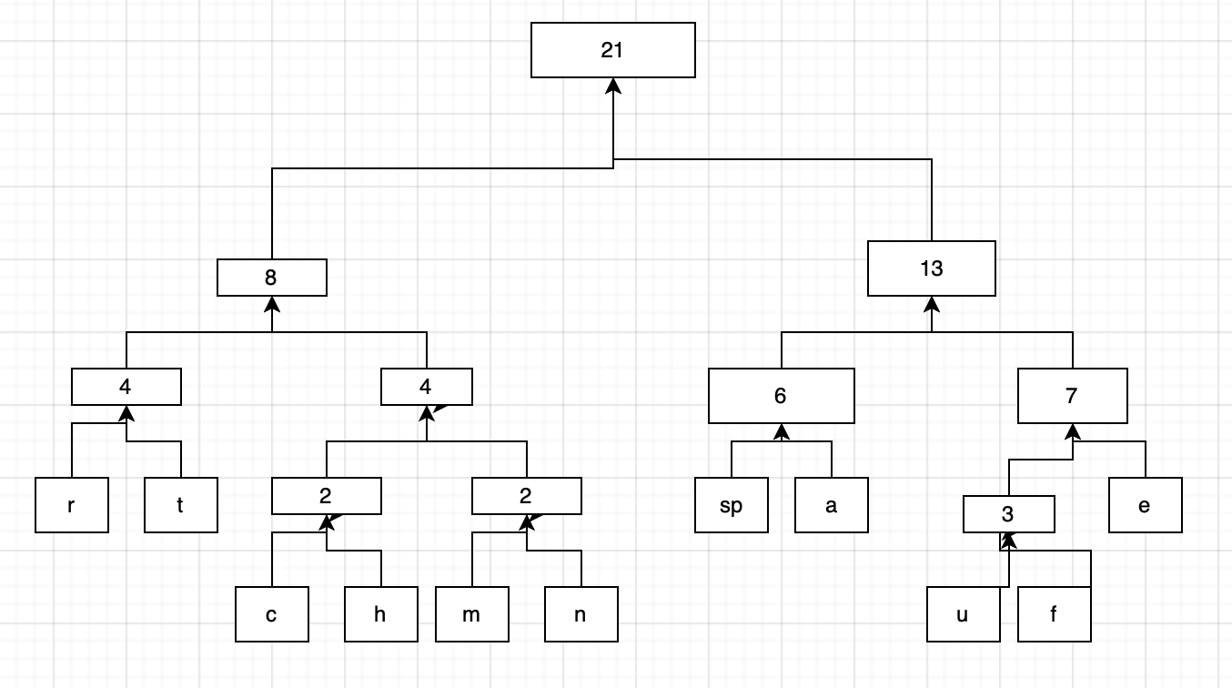

Char | Freq | Code
r | 2 | 000
t | 2 | 001
c | 1 | 0100
h | 1 | 0101
m | 1 | 0110
n | 1 | 0111
 | 3 | 100
a | 3 | 101
u | 1 | 1100
f | 2 | 1101
e | 4 | 111
Now encode “create a huffman tree”
0100 000 111 101 001 111 100 101 100 0101 1100 1101 1101 0110 101 0111 100 001 000 111 111

- Based on the following Huffman tree and binary sequence, what is the text

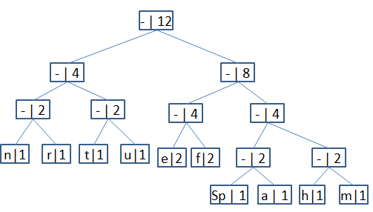

1110011101101111111010001100010001100100

huffman tree

